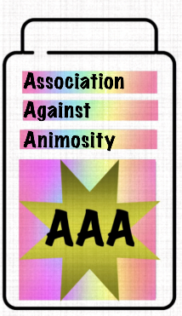
The Triple a party
10235 Parkglenn way,
Parker, CO 80138
(720)-447-9234
timothy.granado@cecstudents.org
Presidential candidate Giac-Long Le
I am writing to you to discuss an important topic concerning our policy going forward. The Triple a Party is completely pro-environment. I feel that our party should plan on making more environmentally friendly jobs. I suggest that our campaign advocate against the coal industry and other industries that are harmful to the environment. I also suggest that you advocate for electrical energy.

